**JAIN UNIVERSITY**

**NAME – ALOK SINGH**

**USN- 22BTRAD003**

**1. Write a Scala program to check two given integers, and return true if one of them is 30 or if their sum is 30** CODE:-

object scala_basic

{ def test(x:Int, y:Int) :

Boolean = { x == 30 || y == 30 || x + y == 30

}

def main(args: Array[String]): Unit = {

println("Result: " + test(30, 0)); println("Result: " + test(25, 5)); println("Result: " + test(30, 20));

println("Result: " + test(25, 20));

}

}

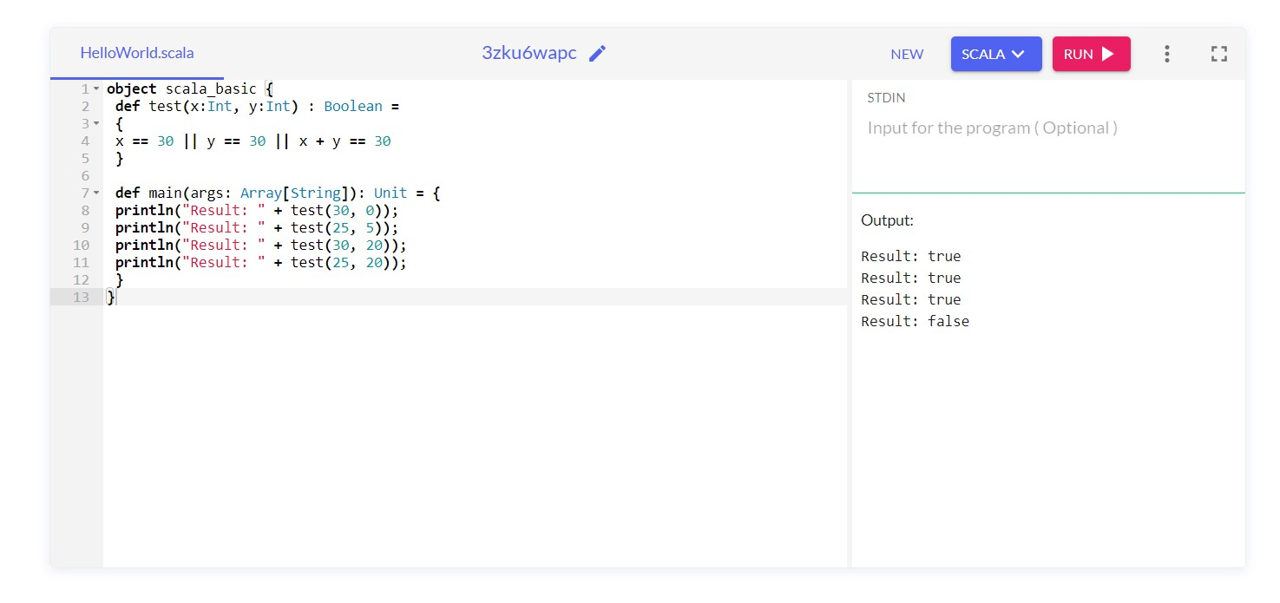

**2.Check if X is Greater or Y**

**CODE:-**

object scala_basic { def test(x:Int, y:Int) : Unit =

{

if(x==y){

println("X is Equal to Y")

}

else if(x>y){

println("X is greater than Y")

}

else{

println("Y is Grater than X")

}

}

def main(args: Array[String]): Unit = { test(30, 0); test(25, 5); test(30, 20); test(25, 20);

}

}

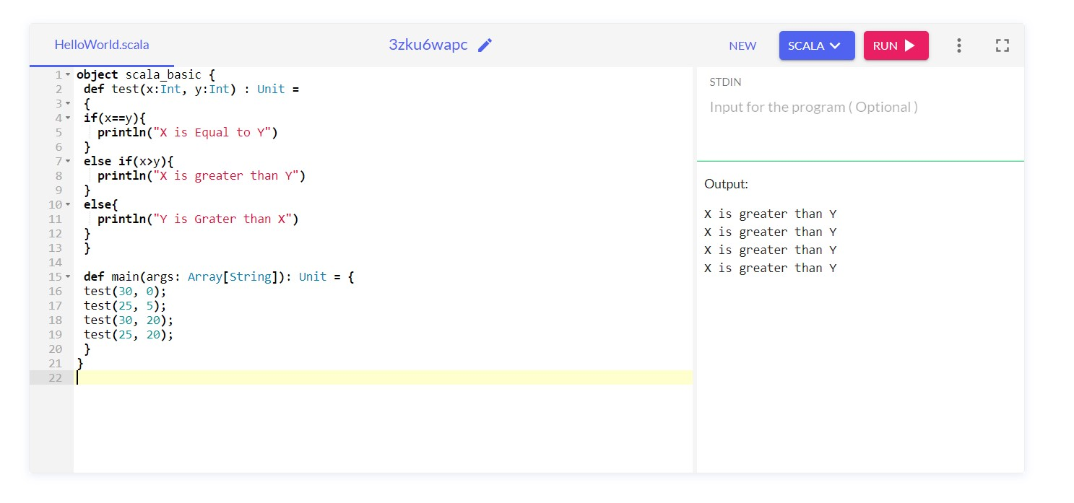

**3. Write a Scala program to check a given integer and return true if it is within 20 of 100 or 300.** object scala_basic {

def test(x:Int) : Boolean =

{

Math.abs(100 - x) <= 20 || Math.abs(300 - x) <= 20

}

def main(args: Array[String]): Unit = { println("Result: " + test(115)); println("Result: " + test(200)); println("Result: " + test(250));

println("Result: " + test(70));

}

}

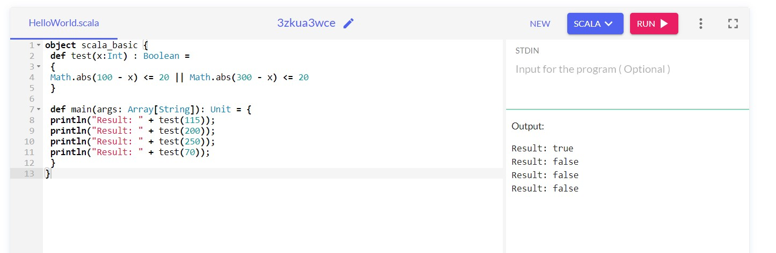

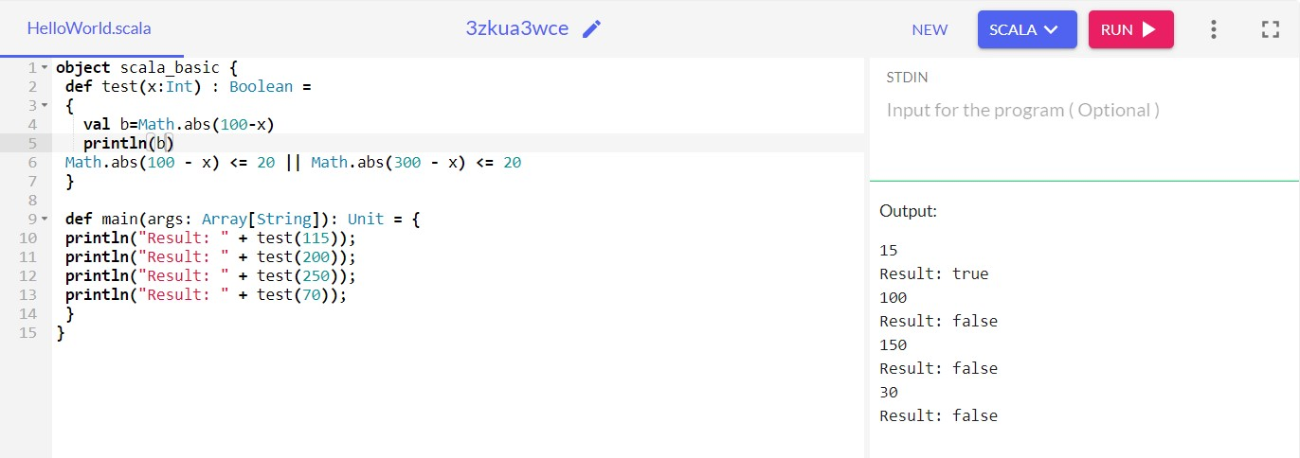

https://github.com/ALOKSINGH/SCALA/blob/main/6SEP23.pdf